Activity 8b: Light, Color, and Temperature
Lab originally written by Jatila van der Veen, with modifications by Erin O’Connor
First: Explain, in one sentence, what is meant by the Electromagnetic Spectrum.

Understanding Color and Temperature
Sunlight was first split into the rainbow of colors by…guess who? Sir Isaac Newton! In addition to figuring out his three laws of motion and how gravity works, he was the first person (in the west, in recorded history, that is) to split sunlight into the rainbow of colors and recombine the colors back into white sunlight.
We will need to understand a LOT about light in this course. Since we can’t play with lights and spectroscopes in class, we will play with simulations.
Goal: In this activity you will gain an understanding of how the spectrum of radiation given off by a heated body (star, light bulb, planet, living being) is dependent on its temperature.
1. Look up the definition of the term BLACK BODY RADIATION. Write it down:

Black-body radiation has a characteristic, continuous frequency spectrum that depends only on the body's temperature, called the Planck spectrum or Planck's law. ... As the temperature increases past about 500 degrees Celsius, black bodies start to emit significant amounts of visible light.

2. Go to this URL:
https://phet.colorado.edu/sims/html/blackbody-spectrum/latest/blackbody-spectrum_en.html
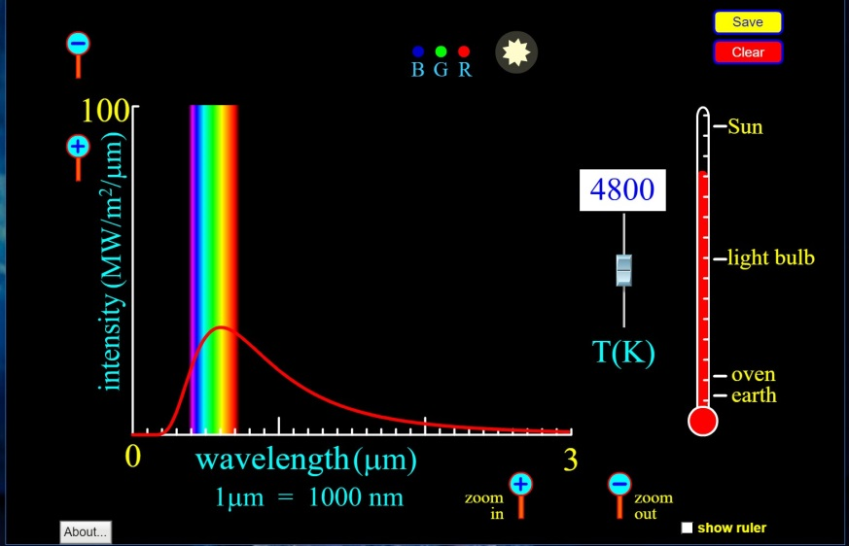
This simulation allows you to change the temperature of an object and see the spectrum of the light it puts out. The peak in the spectrum – the wavelength where the intensity of the light is maximum – tells you the temperature of the surface of that object.
Click on “Graph values” and “Labels” to turn on the labels.
1. The simulation opens up to the Sun.
a. What is the temperature of the surface on the Sun, as indicated by the thermometer on the right side of your screen?

b. At what color is the peak of the light spectrum?

c. The horizontal scale tells you wavelength. The authors of this simulation have chosen micrometers (µm) for the unites. 1 µm = 10⁻⁶ m = 10³ nm. What is the wavelength where the peak of the light output is?

2. Lower the thermometer to the temperature of a light bulb, using the slider.
a. What is the blackbody temperature of a light bulb, as read on the thermometer?

Use the + and – symbols for the vertical and horizontal axes to change the scale, so that you can see the peak of the spectrum better.
b. At what part of the spectrum does the peak output of a lightbulb occur – visible, infrared (longer wavelength than red) or ultraviolet (shorter wavelength than violet)?

c. What is the wavelength of the peak in radiation, approximately? Read this on the horizontal axis.

3. Lower the thermometer to the temperature of the Earth.
a. What is the blackbody temperature of Earth?
Use the + and – buttons on the horizontal and vertical axes until you can see the spectrum.
b. Where is the peak of the Earth’s spectrum?
c. What is the wavelength of the peak of the Earth’s black body spectrum?

4. Lastly, move the slider on the side of the thermometer up to Sirius A. Sirius A is a white dwarf.
a. What is the surface temperature of Sirius A?

b. Where is the peak of its spectrum – visible, infrared, or ultraviolet?

c. What is the wavelength of the peak of the black body spectrum of Sirius A?

Test your understanding by answering the following questions, based on your observations in these simulations.

1. Which is hotter, a blue star or a red star?

2. Is a star ever too hot to see at all, even if the peak of its spectrum is in the ultraviolet?
Explain your reasoning based on what you observe in the simulation
3. The surface temperature of an average mammal like you is around 300 Kelvin. Slide the temperature slider so that the thermometer reads 300K.
What is the peak wavelength in microns?

What portion of the electromagnetic spectrum is this in?

4. Move the temperature slider to 3000K, the temperature of the surface of a red giant or red dwarf star.
In what portion of the electromagnetic spectrum is the peak of its spectrum?
What is the peak wavelength?

What color would the star appear (look at the color of the star at the top of the screen).

5. What is the color of a star with a surface temperature of 7000K?

At what wavelength and spectral color is the peak of its blackbody spectrum?

